WEEK 1:

M1. Assignment

Ancient Egyptian Pharaohs & Queens

Guidelines
- Following the instructions below, you will post your response in the discussion area accompanying this assignment.
- Your post should be two to three paragraphs long, and follow the Discussion Post rubric.
- Respond to 2 of your classmate's posts.

Description
Much of what we known of ancient Egypt is due to the Pharaohs, who ruled the civilization and went to extraordinary lengths to have their memory exist for posterity. Understanding their lives gives tremendous insight into the history and society of the land they ruled. For your first assignment choose one of the Ancient Egyptian Pharaohs or Queens listed below and write a brief biography consisting of two to three paragraphs, then respond to one classmate.
To find information, use the OCC Library databases "Ancient and Medieval History Online" or "Oxford Reference Collection." Both will provide a short synopsis of your subject and get you familiar with some of the History resources available to you. At the end of your biography cite your source(s) in MLA format and post the biography below.
NOTE: The databases can be accessed from home through Ocean Connect and are available to all OCC students. Click on Library Services and scroll through the Alphabetical List.
NOTE: Ancient and Medieval History Online can be found in the "Facts on File" collection of databases.
NOTE: Ancient and Medieval History Online has a "Citation" button on each article that will provide the MLA format. For additional citation information consult the "Citation Resources" link on the Library Services page.
- Ahmose I
- Akhenaten
- Amenemhet I
- Amenemhet III
- Amenhotep I
- Amenhotep II
- Amenhotep III
- Cheops
- Chephren
- Djoser
- Hatshepsut
- Horemheb
- Menes
- Menkaure
- Mentuhotep II
- Merenptah
- Nefertari
- Nefertiti
- Ramses I
- Ramses II
- Ramses III
- Senwosret III
- Seti I
- Tiye (Wife of Amenhotep III)
- Tut'ankhamun
- Tuthmosis I
- Tuthmosis III

Assignment 2:

Interpreting Visual Evidence

Guidelines
- Write a one to two page paper in MS Word and answer the questions below.
- Your papers must be submitted in MLA format. Citation information can be found through the OCC Library at the Link below. In addition to providing citation information for the MLA format, The Purdue Owl resource covers grammar and the basics of writing a research paper.
Library Citation Sources and Formatting (Links to an external site.)Links to an external site.
- Submit your .doc or .docx files below.

Description
The assignment for this unit will be to examine visual evidence and interpret it. As we learned in Unit 1, historians must often use sources other than written documents to understand ancient civilizations. The pharaoh Hatshepsut has left us busts, statues, and engravings detailing her reign. However, during the reign of her successor Thutmose III, many of her images were defaced and her name erased - though it has also been suggested that it was done by his son Amenhotep II. Images A and B show statues of the pharaoh Hatsheptsut, A has been defaced while B still shows the crown and false beard marking her as the Pharaoh. Images C and D show Hatshepsut in a more powerful role when compared to Thutmose III.

Respond to the following questions:
- The Egyptian Pharaohs carefully controlled their public image, based on images C and D, how might the relationship between Hatshepsut and Thutmose have been interpreted?
- What can these images and statues tell us about gender roles and the expectations placed on the Pharaoh?
- Evidence shows that Hatshepsut was likely a legitimate Pharaoh, what may have motivated her successors to tarnish her image after her death?
Images A and B - Hatshepsut was shown to look as much like her royal predecessors as possible, particularly focusing on looking god-like and authoritative. Certain attributes such as the crown, flail, sceptre, and false beard were part of the royal regalia.
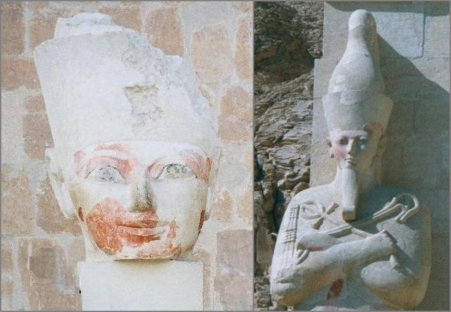
"Hatshepsut" by JCarriker, uploaded by Giorces - Own work. Licensed under CC BY 2.5 via Wikimedia Commons - https://commons.wikimedia.org/wiki/File:Hatshepsut.jpeg#/media/File:Hatshepsut.jpeg
Image C - Hatshepsut is shown in the center of this image making an offering to the God Amun. She wears a royal helmet while Thutmose III stands behind her wearing the Crown of Upper Egypt.
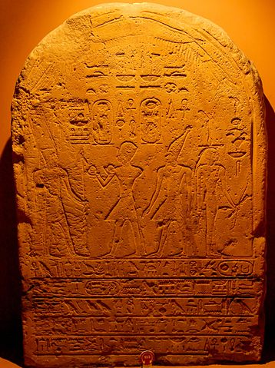
"Dual stela of Hatsheput and Thutmose III (Vatican)" by Sebastian Bergmann - http://www.flickr.com/photos/sebastian_bergmann/1440471961/in/set-72157602146704582/. Licensed under CC BY-SA 2.0 via Wikimedia Commons - https://commons.wikimedia.org/wiki/File:Dual_stela_of_Hatsheput_and_Thutmose_III_(Vatican).jpg#/media/File:Dual_stela_of_Hatsheput_and_Thutmose_III_(Vatican).jpg
Image D - In this stele, Thutmose wears the warrior crown while Hatshepsut wears the double crown of Upper and Lower Egypt while wielding a mace. Hatshepsut again takes the more prominent role.
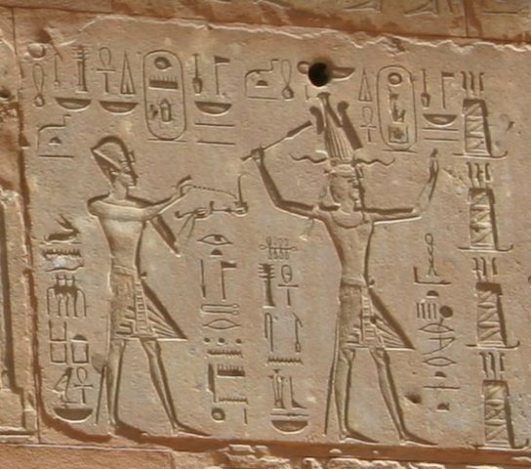
"Thutmose III and Hatshepsut" by Markh - http://en.wikipedia.org/wiki/Image:Thutmose_III_and_Hatshepsut.jpg. Licensed under Public Domain via Wikimedia Commons - https://commons.wikimedia.org/wiki/File:Thutmose_III_and_Hatshepsut.jpg#/media/File:Thutmose_III_and_Hatshepsut.jpg

Assignment 3: Description
The city-states of Athens and Sparta had drastically different visions for the government of their populations. Using the links below, read "The Polity of the Spartans" and "The Polity of the Athenians", then explain some of the key differences between the poleis of Athens and Sparta. Do you perceive any bias in the texts? Why do you think this might be so?
Your papers must be submitted in MLA format.

Assignment 4: M4. Assignment

Alexander the Great

Guidelines
- Following the instructions below, you will post your response in the discussion area accompanying this assignment.
- Your post should be two to three paragraphs long, and follow the Discussion Post rubric.
- Respond to 2 of your classmate's posts.

Description
Much of what we known of Alexander the Great comes from very few sources, many of them written long after his death. Below you will find the preface to the Anabasis of Alexander, or the History of the Wars and Conquests of Alexander the Great, by Arrian of Nicomedia. Arrian was born near the end of the first century C.E. and thus wrote hundreds of years after the death of his subject relying upon the sources he mentions below.
For this assignment, you will follow the link below to the Project Gutenberg edition of the Anabasis of Alexander and choose one of the chapters that you find interesting. (The chapters are rarely longer than a few paragraphs) After reading the chapter, post a brief summary of it's contents to the Assignment 4 discussion below. Does Alexander do anything in this episode that would support his 'Greatness'? Also briefly comment on how much authority we should place on Arrian's account of Alexander's conquest based on the preface below. Set the book number and chapter title that you select as the title of your post.
The Anabasis of Alexander (Links to an external site.)Links to an external site.
Note: You many need to click the link "read this book online: HTML"

Preface
"I have admitted into my narrative as strictly authentic all the statements relating to Alexander and Philip which Ptolemy, son of Lagus,and Aristobulus, son of Aristobulus, agree in making; and from those statements which differ I have selected that which appears to me the more credible and at the same time the more deserving of record. Different authors have given different accounts of Alexander’s life; and there is no one about whom more have written, or more at variance with each other. But in my opinion the narratives of Ptolemy and Aristobulus are more worthy of credit than the rest; Aristobulus, because he served under king Alexander in his expedition, and Ptolemy, not only because he accompanied Alexander in his expedition, but also because he was himself a king afterwards, and falsification of facts would have been more disgraceful to him than to any other man. Moreover, they are both more worthy of credit, because they compiled their histories after Alexander’s death, when neither compulsion was used nor reward offered them to write anything different from what really occurred. Some statements made by other writers I have incorporated in my narrative, because they seemed to me worthy of mention and not altogether improbable; but I have given them merely as reports of Alexander’s proceedings. And if any man wonders why, after so many other men have written of Alexander, the compilation of this history came into my mind, after perusing the narratives of all the rest, let him read this of mine, and then wonder (if he can)."

M5. Assignment

Emperors of Rome

Guidelines
- Following the instructions below, you will post your response in the discussion area accompanying this assignment.
- Your post should be two to three paragraphs long, and follow the Discussion Post rubric.
- Respond to 2 of your classmate's posts.

Description
For this assignment choose one of the Roman Emperors listed below, write a brief biography (two to three paragraphs), and post it to the Assignment 5 discussion. Try to choose an Emperor not already posted by a classmate and when you are finished, comment on one of your classmate's biographies. You may choose a Emperor not on the list if you wish.
- Julio-Claudian Dynasty
  - Augustus
  - Tiberius
  - Caligula
  - Claudius
  - Nero
- Year of Four Emperors and the Flavian Dynasty
  - Galba
  - Otho
  - Vitellius
  - Vespasian
  - Titus
  - Domitian
- Nerva-Antonine Dynasty
  - Nerva
  - Trajan
  - Hadrian
  - Antoninus Pius
  - Marcus Aurelius
  - Commodus
- Severan Dynasty
  - Septimius Severus
  - Caracalla
  - Geta
  - Macrinus
  - Elagabalus
  - Severus Alexander

